Travel Advisory

Meeting Venue:

Conference Room, First Floor, National Institute of Urban Affairs (NIUA), Core 4 B, India Habitat Centre, Lodi Road, New Delhi – 110003

Commutation:
For local travel in Delhi, guests can download the OLA app/Uber app for radio taxis. The auto rickshaws are also easily available for all destinations within city. The revised fare is INR 25/- for first 1.5 kilometres (upon downing the meter) and thereafter INR 9.5/- per kilometre for every additional kilometre. While commuting to the venue, please mention – India Habitat Centre, Lodhi Road as a destination

Local Weather:
The temperature in New Delhi during the month of December usually varies from 12 to 22 degrees Celsius. Windcheater jackets / inter outfits can be layered to keep yourself warm.

Currency
The official currency of India is Indian Rupee (Rs or INR). The exchange rate is approximately 1 USD = 85 INR. Please note that few restaurants do not accept credit cards so it is advised that you bring sufficient cash to cover any additional expenses.

Some Common Hindi Words
Hello = Namaste
Yes = haa
No = nahi
Today = aaj
Tomorrow = kal
Okay/good/ = thik hai
Stop= ruko
Water = pani
How much this cost = ye kitne ka hai
This is expensive = yeh bahut mehanga hai
What happened = kya hua

Area Map of Lodhi Road, New Delhi
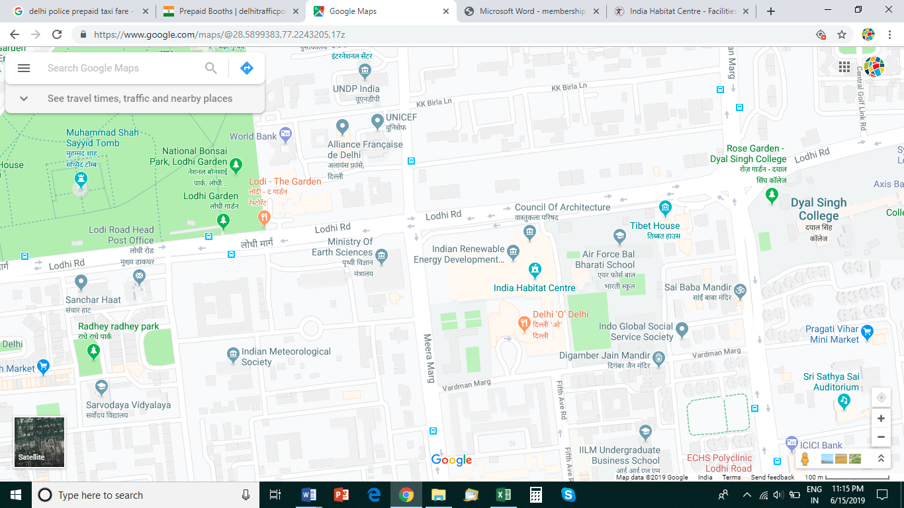

Layout Map of India Habitat Center

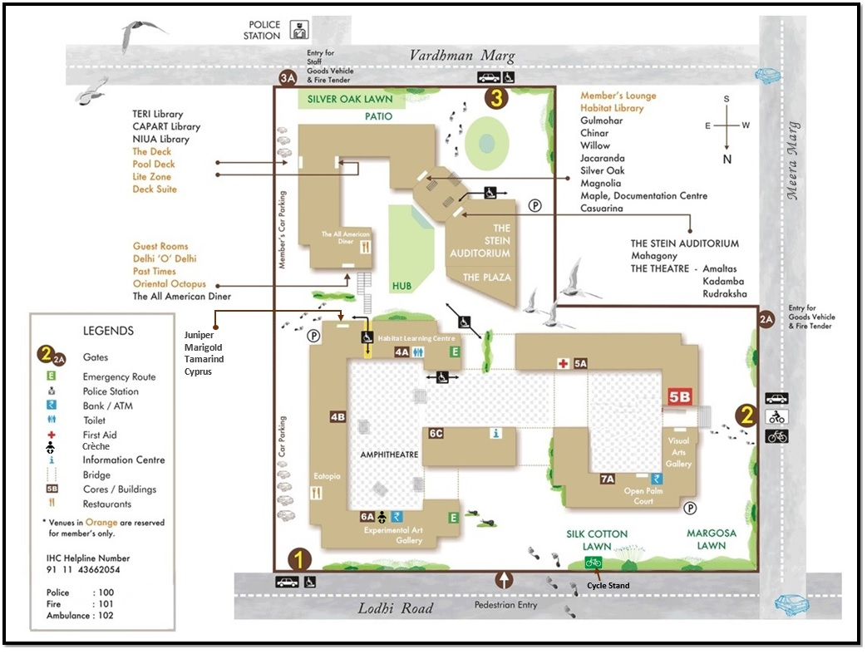
Layout Map of Venue, India Habitat Center
NIUA
NIUA
Main Entrance
Places for Shopping in Delhi

- Delhi Haat, Delhi, Opposite INA Market, South Delhi (All kinds of handcrafted products)
- Janpath Market, Connaught Place (Trendy clothing, jewelry and accessories)
- Sarojini Nagar Market, Sarojini Nagar, near Delhi Haat (All-you-can-carry, western outfits, denims, accessories)
- Lajpat Nagar Market, Lajpat Nagar (Indian-wear, accessories, home textiles and accents)
- Khan Market, Humayun Road (Branded and designer clothing, books, and organic products)
- South Extension, Ring Road ((Branded and designer clothing, books, and organic products)
- Karol Bagh, Karol Bagh (Festive outfits, all kinds of bling)
- Chandni Chowk, Chandni Chowk, Old Delhi (sarees, festive outfits, jewelry, lighting fixtures and electronic goods, spices)
- Sundar Nagar, Connaught Place (One-of-a-kind garments, antique-style homeware)

Places to Visit

https://delhitourism.travel/places-to-visit-in-delhi

- India Gate
- Red Fort
- Chandini Chowk
- Humayun’s Tomb
- Qutab Minar
- Connaught Place
- Lotus Temple
- Purana Qila
- Akshardham Temple

If you planning to visit Taj Mahal (Agra)

Official Website : https://www.tajmahal.gov.in/

ABOUT AGRA
Taj Mahal is situated on the banks of the Yamuna river in the Indian state of Uttar Pradesh. It is located 220 kilometres south of the national capital New Delhi. It is frequented by tourists from every corner of the world as it houses one of the seven wonders of the world. The Taj Mahal is considered the finest example of Mughal architecture, a style that combines elements from Persian, Indian, and Islamic architectural styles. Adjacent to the Taj Mahal there are many other Mughal-era buildings, most notably the Agra Fort and Fatehpur Sikri, all of which are UNESCO World Heritage Sites.

Tickets:
The guest should preferably book their tickets online in order to avoid standing in queue.

The details of buying ticket online is as follows:
- The link to purchase ticket online is https://asi.payumoney.com/#/
- On the page select “CITY – AGRA’’ and “MONUMENTS – TAJ MAHAL and AGRA FORT”
- Select date as “ OCTOBER 13, 2019”
- Select time as “10:30 AM for TAJ MAHAL” (ticket is valid for three hours)
- Select time as “2:30 PM for AGRA FORT”
- Fill personal details
Don’t worry incase you are unable to purchase ticket online, it can be purchased from the ticket counter at the monument.

TRAVEL ADVISORY
- Mobile phones are to be kept switched off or on silent mode.
- Eating and smoking is strictly prohibited inside Taj Mahal.
- Arms, ammunitions, fire, smoking items, tobacco products, liquor, eatables (Toffees), head phones, knives, wire, mobile charger, electric goods (except camera), Tripods are also prohibited.
- Avoid carrying big bags and books inside the monument, this may increase your security check time.
- Drone camera is strictly prohibited inside the Taj Mahal.
- Photography is prohibited inside the main mausoleum.
- No Polluting vehicles are allowed within 500 mts. Radius of Taj Mahal.
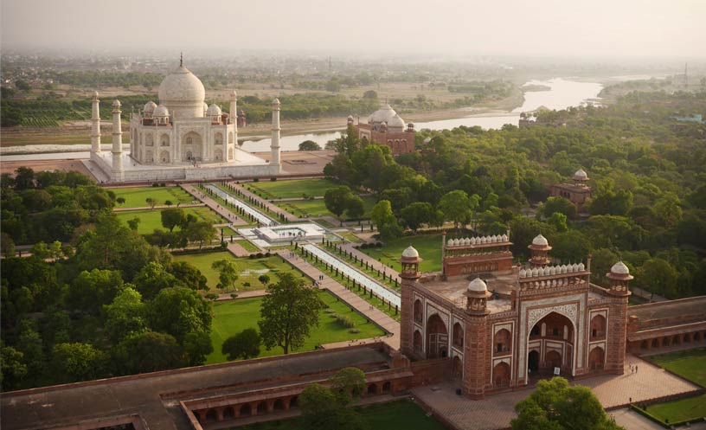
Figure 1 Taj Mahal

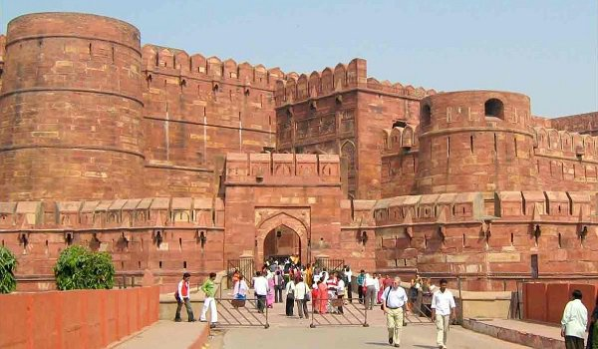
Figure 2 Agra Fort

