REPORT FOR TRAINING ON HOW TO DEVELOP SYLLABUS AND MAKE REVIEW
Tuesday, 06 September 2022, 05:00 pm – 06:00 pm

Title: | Urban Resilience and Adaptation for India and Mongolia: curricula, capacity, ICT and stakeholder collaboration to support green & blue infrastructure and nature-based solutions – URGENT
Number: | 619050-EPP-1-2020-1-DE-EPPKA2-CBHE-JP
Coordinator: | National University of Mongolia
Participants: | Mongolian University of Life Sciences  Khovd University  Urban Planning and Research Institute  National Garden Park of Ulaanbaatar

Objectives of the training:
- To introduce how to develop syllabus and make review

Date: Tuesday, 06 September 2022, 05:00 pm – 06:00 pm
Venue: Online using Microsoft Teams

Schedule:
Time | Topic | Presenter
17:00-17:30 | Syllabus preparation | O.Altansukh, NUM
17:30-17:40 | Video introduction to e-course
17:40-17:50 | Reviews by employer, partner university and department
17:50-18:00 | Poster making
18:00-18:10 | Q&A and open discussion

The national coordinator of the URGENT project has been organized the technical training of Mongolian team on how to develop syllabus on 6th September 2022 between 5 and 6 PM. All people (12; f-9, m-3) who are responsible to develop syllabus have been participated. All contents of syllabus are explained.

Participants:
№ | Full name | E-mail | Organization
 | Altansukh Ochir | altansukh@num.edu.mn | National University of Mongolia
 | Altanzul Davaa-Ochir | altanzul@toc.mn | Mongolian Sustainable Finance Association
 | Banzragch Dalai | banzragch@muls.edu.mn | Mongolian University of Life Sciences
 | Belguun | belguun@muls.edu.mn | Mongolian University of Life Sciences
 | Enkhchimeg. B | enkhchimeg@seas.num.edu.mn | National University of Mongolia
 | Monkhtuvshin | monkhtuvshin@muls.edu.mn | Mongolian University of Life Sciences
 | Odongerel Sangidorj | odongerel@muls.edu.mn | Mongolian University of Life Sciences
 | Oyunchimeg N | n.oyunchimeg@num.edu.mn | National University of Mongolia
 | Unurnasan Dagva | unurnasan@khu.edu.mn | Khovd University
 | Amarjargal Ayurzana | amarjargal@khu.edu.mn | Khovd University
 | Uranbaigal | info@upri.ub.gov.mn | Urban Planning and Research Institute
 | Ariunsanaa Bat-Erdene | ariunsanaa@seas.num.edu.mn | National University of Mongolia
The training video record: https://youtu.be/uIvaNTOMZPA

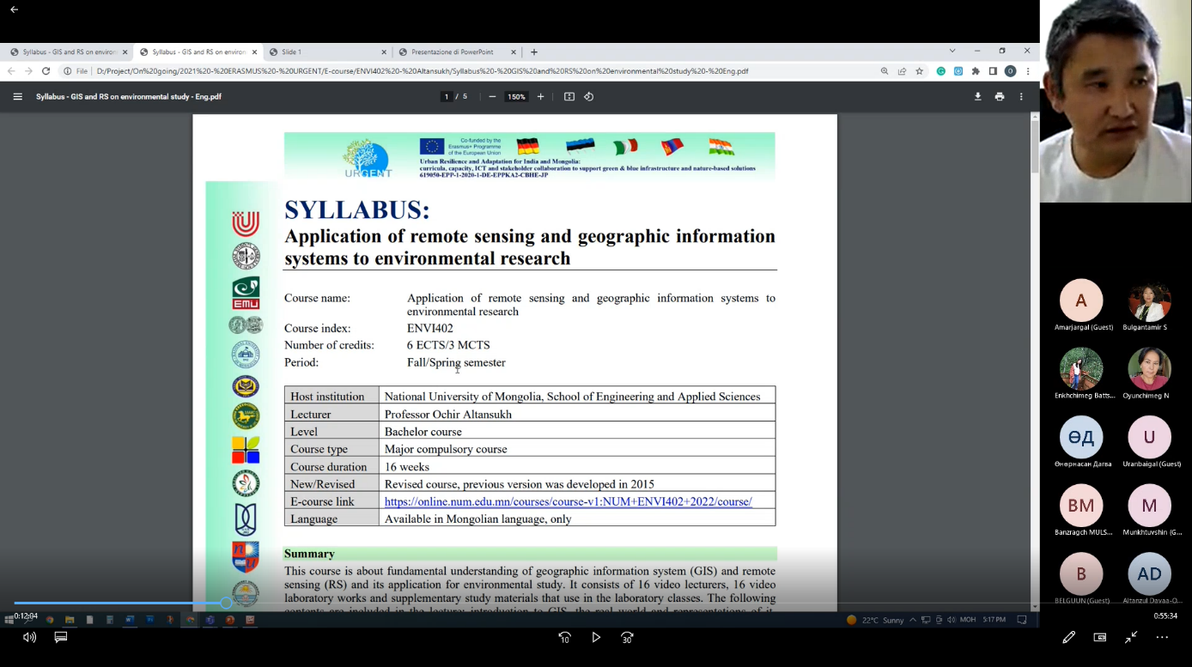

Reported by Ochir ALTANSUKH, National University of Mongolia

