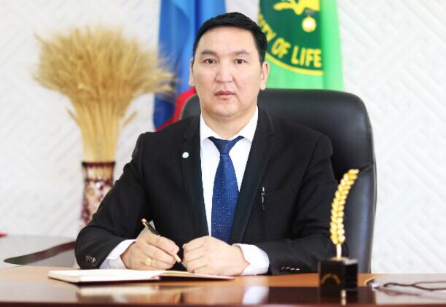 | BUYANBAATAR Avirmed  Associate professor, PhD  Dean of School of Agroecology,  Mongolian University of Life Sciences (MULS)  Ulaanbaatar, Mongolia  Language(s): Mongolian, English  Office postal address, phone number and e-mail:  Mongolian University of Life Science, Department of Ecology, Zaisan 17024, Khan-Uul district Ulaanbaatar, Mongolia,  e-mail; a_buyanbaatar@muls.edu.mn  Personal web page:  Research gate: https://www.researchgate.net/profile/Buyanbaatar-Avirmed-2
Potential areas for PhD supervision: |  | Supervising experience:
- Soil Fertility  - Agroforestry  - Desertification and land degradation  - Pastureland management  - Improvement of soil fertility  - Urban land rehabilitation |  | - 3 PhD students  - 16 MSc students
Employment history in last 5 years:
- 2018 – Present Dean of the School of Agroecology, MULS
- 2006-2018 Lecturer and Head of Department of Agriculture and soil-agrochemistry, School of Agrobiology, MULS
- 2005-2006 Researcher, Plant Protection Research Institute, MULS

Education – since bachelor degree:
- 2015 Postdoctoral researcher The University of Natural Resources and Life Sciences, Vienna, Austria
- 2011 Postdoctoral researcher The University of Natural Resources and Life Sciences, Vienna, Austria
- 2007-2010 PhD (Agricultural Science) School of Agrobiology, MULS, Ulaanbaatar, Mongolia
- 2005-2006 MSc (Soil science, Agrochemistry) School of Agrobiology, MULS, Ulaanbaatar, Mongolia
- 2001-2005 BSc (Soil science, Agrochemistry) School of Agrobiology, MULS, Ulaanbaatar, Mongolia

Selected recent papers:
- Turtulga B., Buyanbaatar A., Erdenechimeg Z., Dambadarjaa N., and Ariuntsetseg D. “Chicken manure-enhanced soil fertility and productivity” Journal of Agroecology, 2021 (14): 60-69.
- Ganbolor G. and Buyanbaatar A. “Test results of humic fertilizer extraction from biogenic sedimentary rocks” Journal of Agroecology, 2021 (14): 77-87.
- Turtulga B., Buyanbaatar A., Erdenechimeg Z., Dambadarjaa N., and Ariuntsetseg D. “Effects of stimulated poultry manure on wheat yield” Journal of Agroecology, 2020-2021 (13)04: 5-11.
- Buyanbaatar A., Ariumsuren P., Oyuntuya Sh., Tuvshinbayar D., Dambadarjaa N., Orgilbold M., and Tumenjargal M. “Research study of soil, vegetation and pasture carrying capacities of Mogod depression” Journal of Animal Science, 2020 (20)12: 67-73.
- Buyanbaatar A., Ariumsuren P., Tuvshinbayar D., Oyuntuya Sh., Tumenbayar P. and Dambadarjaa N. “Research results of pastureland degradation and desertification in Shine-Ider soum, Khuvsgul Province” Journal of Agroecology 2019 (12)2: 116-120.
- Buyanbaatar A., Ariumsuren P., Tuvshinbayar D., Oyuntuya Sh., Tumenbayar P. and Dambadarjaa N. “Research results of pastureland degradation and desertification in Ulaan-uul soum, Khuvsgul Province”. Journal of Agroecology 2018 (11)01: 97-105.
- Buyanbaatar A. “The effect of ionized water some biochemical properties and yield of potato”, Journal of Central Asian environmental problems, potential solution (2016), International conference, Darkhan.
- Buyanbaatar A. “Effect of irrigation on biochemical properties and yield of wheat”, Journal of Central Asian environmental problems, potential solution”, International conference (2016), International conference, Darkhan.
- Buyanbaatar A. “Possibility of preparing and application of liquid organic fertilizer from raw material of plants”, Journal of Central Asian environmental problems, potential solution (2016), International conference, Darkhan.
- Sayed Mohammad Nazim Uddin, Zifu Li, Ibrahim B Mahmood, Jean Lapegue, Jan Franklin, Adamowski, Pier Francesco Donati, Elisabeth Maria Huba, Heinz-Peter Mang, Buyanbaatar Avirmed, Shikun Cheng “Evaluation of a closed – loop sanitation system in a cold climate: a case from pri – urban areas of Mongolia”, Journal of Environment and Urbanization 2015 (27)2:455-472 https://doi.org/10.1177/0956247815584539

