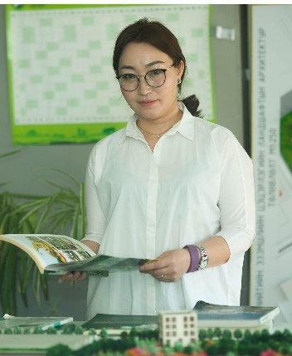 | ODONGEREL Sangidorj  Senior lecturer, PhD  School of Agroecology  Mongolian University of Life Sciences  Ulaanbaatar, Mongolia  Language(s): English, Mongolian, Chinese  Office postal address, phone number, and e-mail:  Mongolian University of Life Science, Department of Ecology, Zaisan 17024, Khan-Uul district Ulaanbaatar, Mongolia,  e-mail: odongerel@muls.edu.mn
Potential areas for PhD supervision: |  | Supervising experience:
- Landscape architecture planning  - Ornamental botany  - Urban green space system planning  - Landscape architecture art |  | - 3 MSc students

Employment history in the last 5 years:
- 2005 – present Mongolian University of Life Sciences, Ulaanbaatar

Membership in professional association:
Since 2012 Director, Mongolian landscape architectural research association

Education – since Bachelor degree:
- 2009-2013 PhD (Environmental Science), Agricultural University, Hohhot, China
- 2004-2006 MSc (Landscape architecture), Mongolian University of Life Sciences, Ulaanbaatar, Mongolia

Selected recent papers:
- Nao minhu, Yi Jin, Wuren qimuge, Aodun gerile, Qing geer. “Study on the Cold resistance and Physiology Basis of Ceratoides”. Chinese Journal of Grassland (2013) 34-39.
- Odongerel.S., I Jin. Wuren Qimuge, Guo Jian Mei, Li Jian Sheng, Yuan Tao “Evaluation of Cold Resistant of 11 Ornamental Shrubs in Inner Mongolia”. Advances in Ornamental horticultural of china (2015) 500-506.
- Odongerel.S., I Jin “Evaluation of Cold Resistant of 11 Ornamental Shrubs in Inner Mongolia”. Journal of Agroecology (2015) №04 (2):
- Batzaya. E., S.Odongerel “The influence of art in landscape architecture”. Journal of Agroecology (2015) №04 (2)
- Erdenezul. B., S.Odongerel. “Problem of Boulevard Planning in Ulaanbaatar”. Journal of Agroecology 2015. 04 (02): 280–285.
- Batzaya. E., S.Odongerel “The influence of art in landscape architecture”. Journal of Land management- 2016 №04 (2):
- Erdenezul. B., S.Odongerel “Boulevard Planning in Ulaanbaatar”. Journal of Land management-2016. 07 (03): 280–285.

