EQUIPMENT AND FACILITIES AT NATIONAL UNIVERSITY OF MONGOLIA
FOR COLLABORATIVE USE TO URGENT PARTNERS
(*purchased by URGENT project)

№ | Equipment | Technical specification | Purpose | Quantity | Photo
Field study and research equipment
 | Drone  DJI Mavic  2 pro* | - Shutter Speed: Electronic Shutter: 8–1/8000s  - Still Image Size: 5472×3648  - Still Photography Modes:  - Single shot  - Video Resolution:  - 4K: 3840×2160 24/25/30p  - 2.7K: 2688x1512 24/25/30/48/50/60p  - FHD: 1920×1080 24/25/30/48/50/60/120p | Field study  Research | 1 | 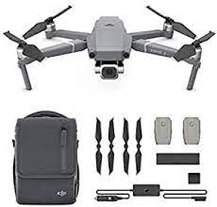
 | Water Level  Meter  Model 101* | For measuring the depth to water in wells, boreholes, standpipes, and tanks, Model 101 Water Level Meters are the industry standard for portable hand operated meters. The Solinst 101 Water Level Meter with P7 Probe features an extremely durable, laser marked PVDF flat tape, with an enhanced dog bone design that is thicker, reducing adherence to the side of well casing. | Field study  Research | 1 | 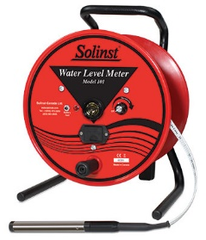
 | Multiple Water  Quality Meter* | Measuring Item: pH(0.00～14.00), ORP(-2.000～2.000mV), DO(0.00～20.00mg/ℓ), EC(0.00～10.00s./m), Salinity(0.00～4.00%), Total Dissolved Solid Volume(0.0～100.0g/ℓ), Seawater Specific Gravity(0.0～50.0), Temperature(-5.00～55.00℃), Turbidity(0.0～800.0NTU), Water Depth(0.0～100m) | Field study  Research | 1 | 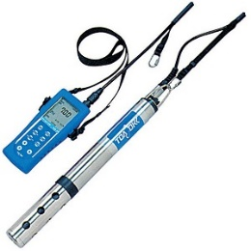
 | Discrete  Interval  Sampler* | The Model 425 Discrete Interval Sampler provides a no-purge sampling option for collecting groundwater samples from discrete levels, and points of inflow, in wells and boreholes. It can also be used for profiling open water bodies, and for sampling above and below oil/product layers, as well as the actual product (e.g. LNAPL and DNAPL). | Field study  Research | 1
 | Sound level  Meter* | - Measurement range: 20-140dB RMS (143.3dB peak)  - Total Noise floor: 19dB(A) Class 1, 25dB(A) Class 2  - Frequency weightings: A, C and Z (un-weighted) simultaneously  - Timers: Duration 1s-24h  - Memory: 2GB (>1 year logging when set to 1 second interval, 999 runs). | Field study  Research | 1 | 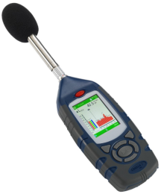
 | Air quality  Meter* | - SO2 - 0-10 ppm,  - CO - 0-100 ppm,  - NO2 - 0-1 ppm,  - O3 - 0-0.5 ppm,  - PM10/PM2.5 - 0 – 1000 ug/m3,  - CO2 - 0-2000 ppm | Field study  Research | 1 | 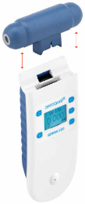
E-teaching facility and E-learning equipment and E-classroom
 | Digital  professor  studio | Developing e-learning and research training infrastructure, curricula contents and learning materials | E-course | 1 | 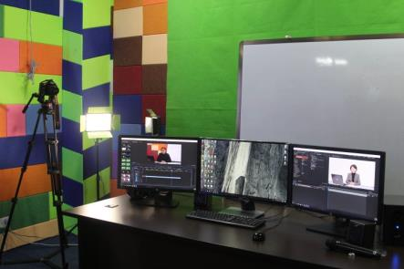
 | Projector | - Epson Home Cinema 2150 Miracst 3LCD Projector  - Color & White Brightness of 2500 Lumens  - Full HD (1920 x 1080) Native Resolution  - 3D Capability: Yes  - Lamp Life: Normal Mode: Up to 4000 hours | E-learning | 1 | 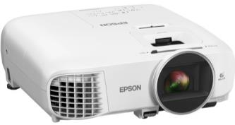
 | E-learning  classroom | - Providing training in ICT-related issues and cutting-edge multidisciplinary topics of environmental studies. | E-learning  E-teaching | 1 | 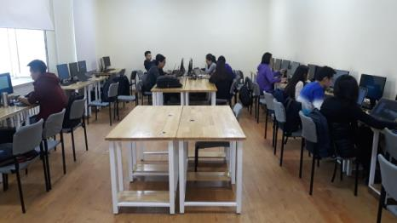
Environmental laboratory and equipment
 | Environmental  engineering  laboratory | - Conduct environmental related research  - Space for research students | Laboratory | 1 | Laboratory photo shown
 | ORP and  pH meter  TOAOK  IM-22P | - To measure oxygen redox potential and pH in water sample | Lab and  field | 2 | 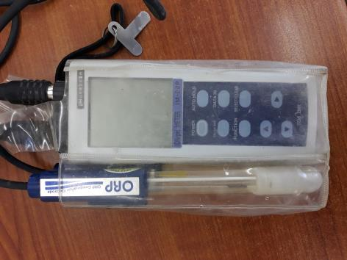
 | EC meter  DO meter  TOAOK  CM-21P  DO-31P | - To measure electro conductivity and dissolved oxygen in water sample | Lab and  field | 1 | 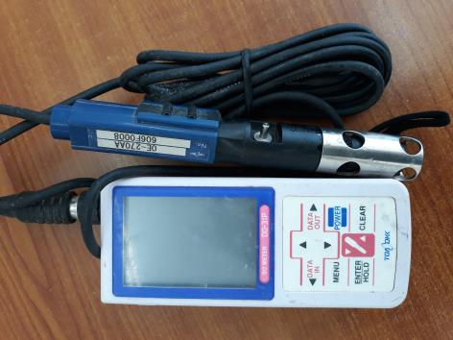
 | Freeze dryer  EYELA  FDU-1200 | - Dry environmental sample that involves freezing the product, lowering pressure, then removing the ice by sublimation | Lab | 1 | 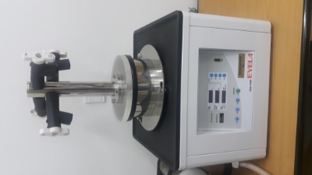
 | Water  Distiller  YAMATO  WG204 | - Distill water and make ion exchanged water to use laboratory experiment | Lab | 1 | 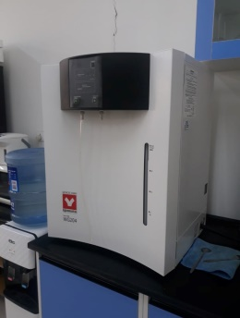
 | Refrigerator  SHARP  80l | - Keep environmental samples in minus Celsius | Lab | 1 | 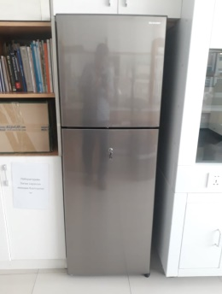
 | Fume Hood  FH1200  Biobase | - Conduct environmental analysis with toxic fume | Lab | 1 | 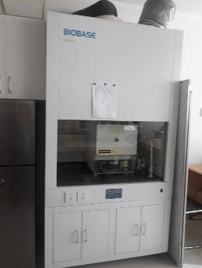
 | Portable  refrigerator | - Keep environmental samples in minus Celsius | Field | 1 | 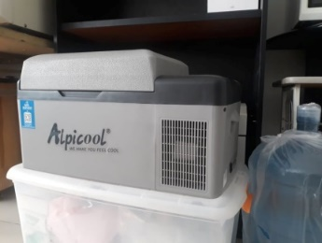
 | Drying over  Heraeus | - Dry environmental samples in plus Celsius | Lab | 1 | 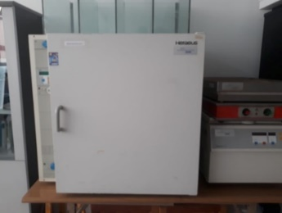

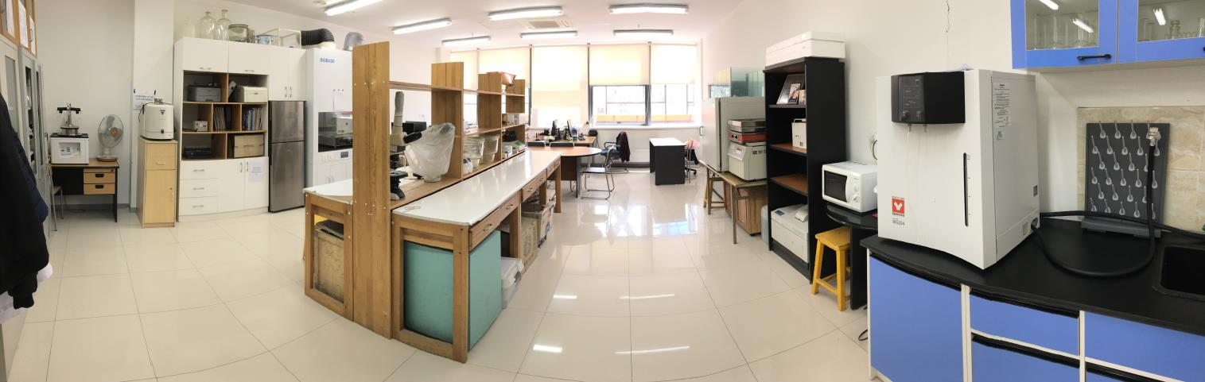

Summer camp in Orkhon Valley National Park
The summer camp is located in Orkhon Valley National Park, Kharkhorin soum, Ovorkhangai aimag. Travel time by car is about 5 hours from Ulaanbaatar capital. The camp has ten gers (Mongolian traditional nomadic house) to work and stay. Also, there is a container with training and cooking rooms. http://www.mongoliagercamps.net/home/pages/about_mongolia_ger
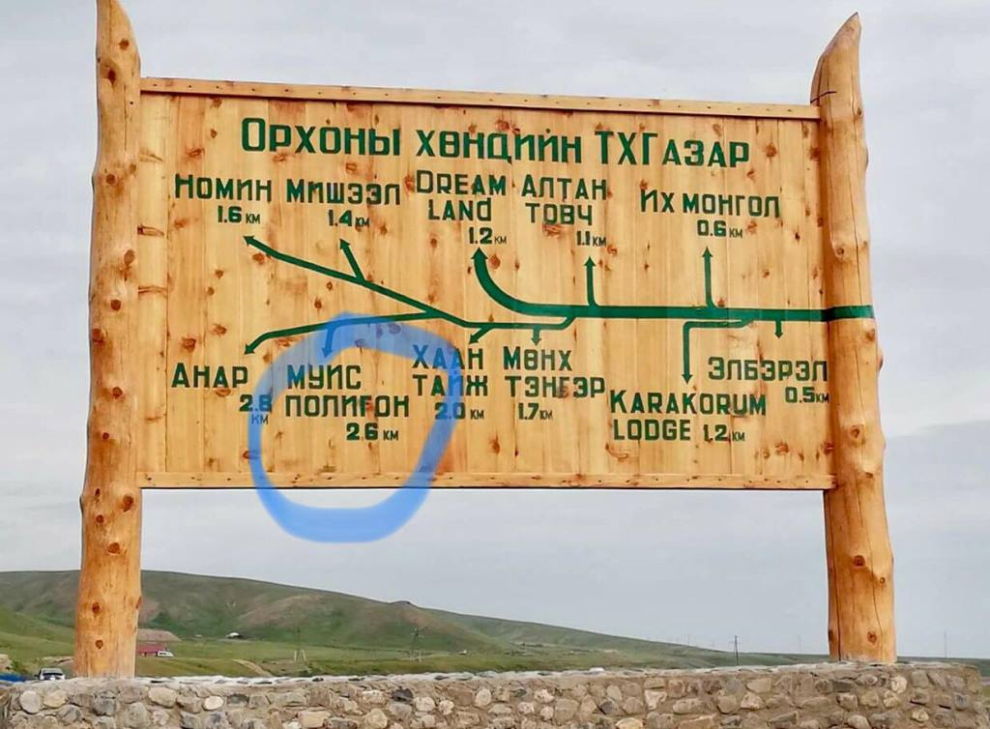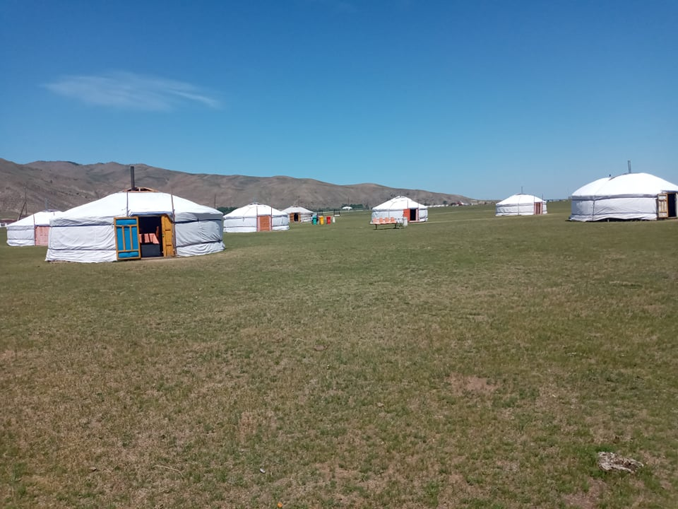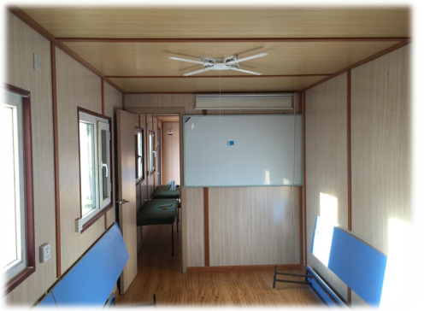
Terms of use: Under the cooperation agreements all equipment and facilities for study and research are provided at no charge
Payment for consumables is a subject to additional agreement on a case-by-case basis
Payment for food and accommodation at summer camp

Contact information: Ochir Altansukh
National University of Mongolia, Ulaanbaatar, Mongolia
Mobile: 976-91993096
E-mail: altansukh@seas.num.edu.mn

